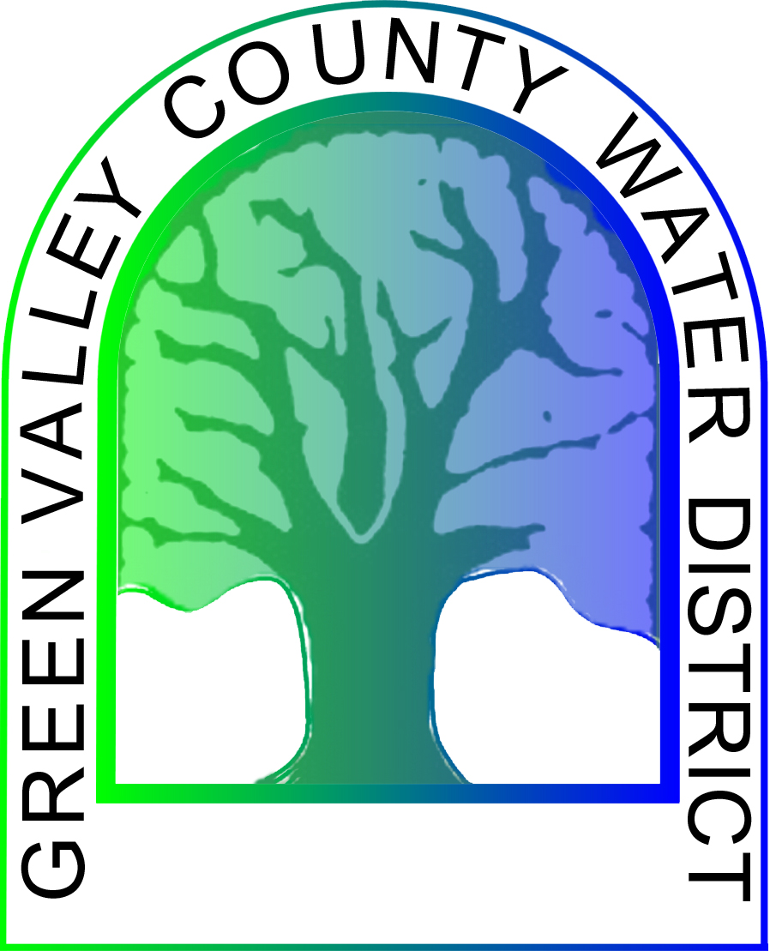
GREEN VALLEY COUNTY WATER DISTRICT
Regular Meeting of the Governing Board
AGENDA
September 14, 2023 - 6:00 PM
Meeting to be held at:
Green Valley County Water District Office
39520 Calle Cascada
Green Valley, CA 91390
(661) 270-0836

Next Numbers:
1. Introduction Res. XX-23-366
Ord. XX-23-39
2. Call to Order by Director _____ at ______ P.M.

3. Pledge of Allegiance.

4. Roll Call: Dave Phillips, Anthony Castaneda Joe Randles, Bob Garth, and Russell Delgado

5. Approval of Agenda
5.1 Motion by:_____ Seconded by:_____ Vote: YES___ NO___

6. Approval of Minutes
6.1 Regular Meeting Aug 10, 2023
Motion by:_____ Seconded by:_____ Vote: YES___ NO___
7. Approval of Treasurer's Reports
7.1 Cash Disbursements 8-01-23 through 8-31-23
Motion by:_____ Seconded by:_____ Vote: YES___ NO___

7.2 Treasurer's Report Aug 2023
Motion by:_____ Seconded by:_____ Vote: YES___ NO___
7.3 Report for Automated Emergency Calls
Motion by:_____ Seconded by:_____ Vote: YES___ NO___
7.4 Board Discussion and Possible Action on Treasurer's Reports
Motion by:_____ Seconded by:_____ Vote: YES___ NO___
8. PUBLIC COMMENT PERIOD ON AGENDA AND NON-AGENDA ITEMS
8.1 Any member of the public may address the Board regarding any agenda or non-agenda item that are within the Board's jurisdiction at this point on the agenda.

8.2 Board member's communication. Board members may announce items of general interest relating to matters within the Board's jurisdiction. There will be no discussion, voting or formal action taken on such items.
9 General Manager's Report
9.1 Report
9.2 Board Discussion and Possible Action on General Manager's Report
Motion by:_____ Seconded by:_____ Vote: YES___ NO___
9.3 Board Discussion and Possible Action on Capital Improvements and Long-term Projects
Motion by:_____ Seconded by:_____ Vote: YES___ NO___
10. Board Presentations
THE FOLLOWING ITEMS ARE FOR BOARD DISCUSSION AND POSSIBLE ACTION UNLESS OTHERWISE NOTED:

10.1 Project Updates: Pipeline Project, Additional Well and Hauling Water
Motion by:_____ Seconded by:_____ Vote: YES___ NO___
10.2 Baranco Water Tank Maintenance Project Progress Report
Motion by:_____ Seconded by:_____ Vote: YES___ NO___
11. Agenda Items for Next Regular Meeting, Oct 12, 2023
12. Meeting Adjourned
Adjournment to next Regular Meeting October 12, 2023 held at the Green Valley County Water District Office, 39520 Calle Cascada, Green Valley, CA

Motion by:_____ Seconded by:_____ Vote: YES___ NO___

Adjournment at _____ P.M.

A copy of the agenda is available for examination by the public at the District office of the Board during regular business hours. Please call the office at (661) 270-0836 for general information about the agenda. Questions about specific items on the agenda should be directed to a staff person.
Material presented to the Board as part of testimony that is to be made part of the record must be left with the Board. This includes photographs, slides, charts, diagrams, etc.
All Board files pertaining to the items on the agenda are hereby made a part of the record submitted to the Board by staff for its consideration prior to action on the related items.

